**SCREENSHOT FILE**

**Scaling the EC2 Instance Based on Monitored CloudWatch Metrics**

**Course-end Project 3**

**Step 1: Create Launch Template**

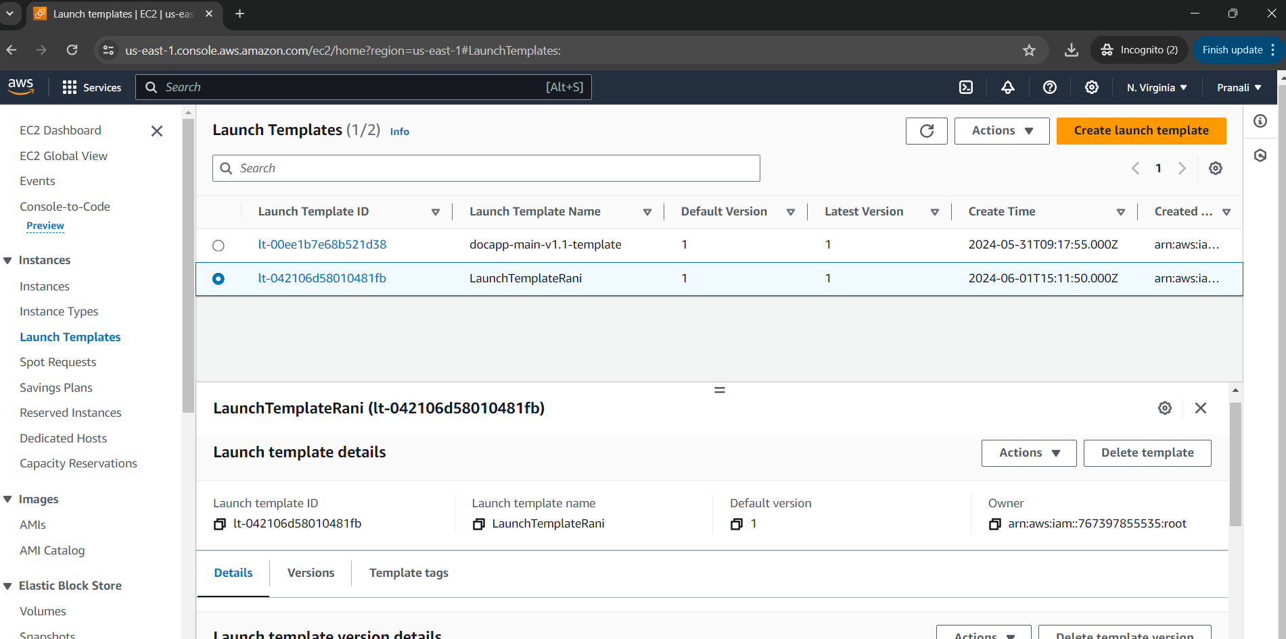

**Step 2: Create Auto Scaling Group and Application Load Balancer**

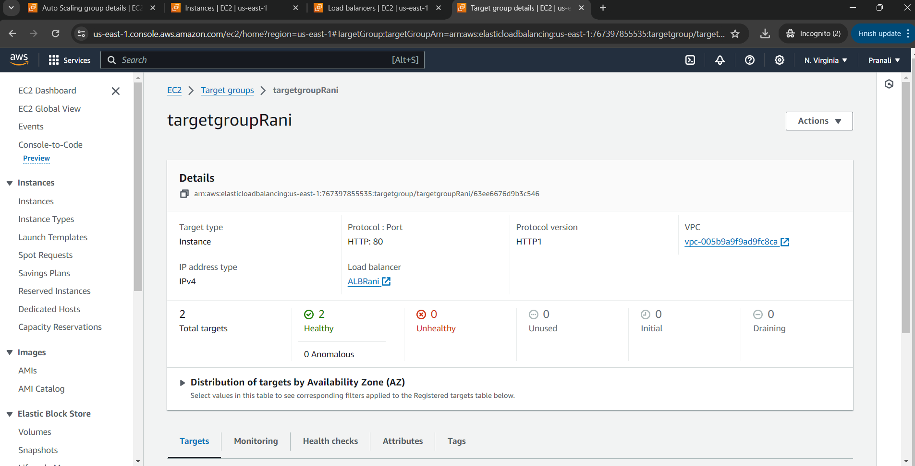

**Step 3: Test the Application Load Balancer.**

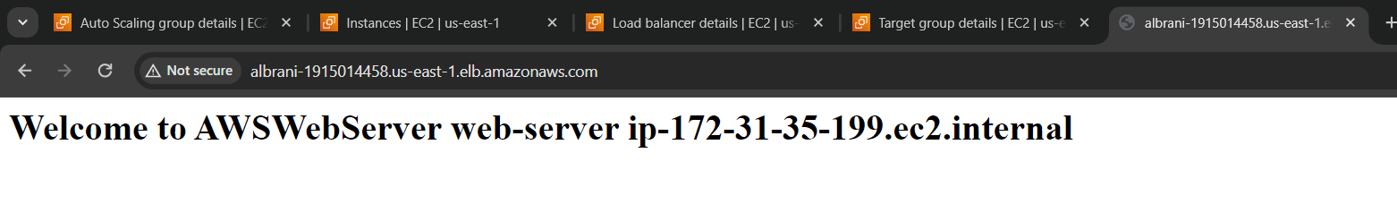

**Step 4: Add Dynamic Scaling Policy to ASG**

**Step 5: Test Scale In and Scale Out Operations.**

